# BUILD A EMPLOYEE TRAVEL APPROVAL APPLICATION FOR CORPORATAES

**INTRODUCTION**

* 1. **OVERVIEW**

**Our project report outlines the process and procedures involved in managing travel requests and approvals in an organisation. The purpose of this project is to streamline the travel approval process and make it more efficient and cost – effective for the organization.**

* 1. **PURPPOSE**

**This type of project would typically involve the development and implementation of a software application are online platform that allows employees to submit travel request, including information such as the purpose of the trip, destination, dates, and estimated costs. The system would also include an approval workflow, where managers or others designated personnel can review and approve are deny the requests based on budgetary constraints, business need are other factors.**

**Benefits of travel approval project can include better visibility and control over employee travel expenses, increases complains with company travel policies, and streamlined communication between employees and management regarding travel plans.**

**Overall, the specific use and benefit of a travel approval project would depend on the goals and requirements of the organization implementing it.**

**2. PROBLEM DEFINITION & DESIGN THINING**

**2.1 EMPATHY MAP**

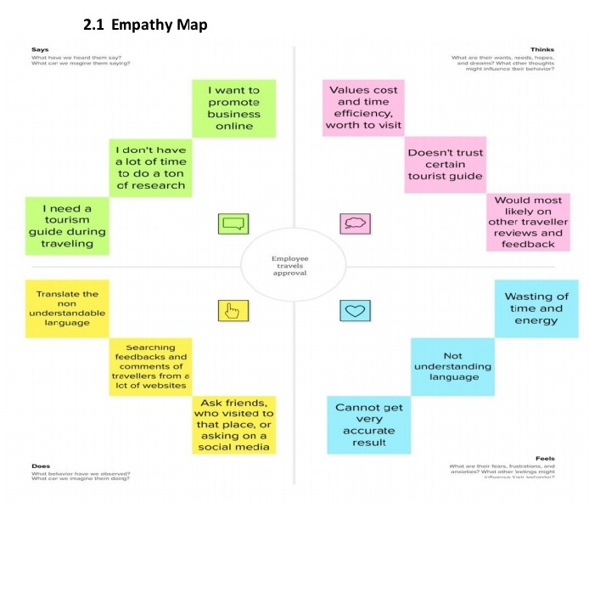

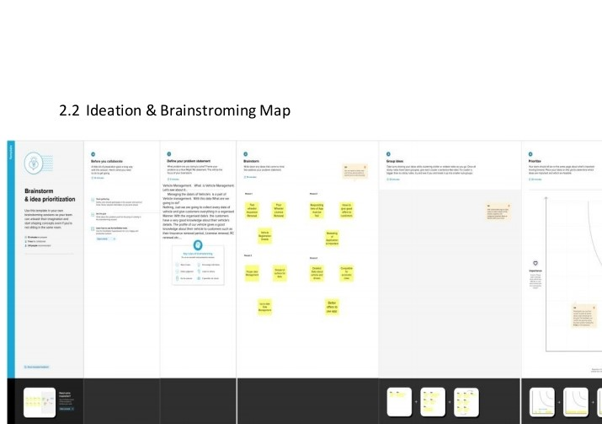

**3. RESULT**

**2.3 Data Model**

|  |  |
| --- | --- |
| **Object name** | **Field name** |
| Travel approval | |  |  | | --- | --- | | Field label | Data type | | **travel approval** | **Look up** | | **Destination date** | **text** | | **Out of state** | **checkbox** | | **Purpose of trip** | **Text area** | | **status** | **picklist** | | **Status indicator** | **formula** | | **Total expenses** | **Roll-up summary** | | **Travel approval #** | **auto number** | | **Trip and date** | **Date** | | **Trip end date** | **date** | |
| Expenses item | |  |  | | --- | --- | | Field label | Data type | | **amount** | **currency** | | **Expenses item number** | **Auto number** | | **Expenses field** | **Pick list** | | **Travel approval** | **Master-detail** | |
| department | |  |  | | --- | --- | | Field label | Data type | | **Department code** | **text** | | **Department name** | **text** | |

**2.4 Activity screenshots**

**Home page of sales force Account**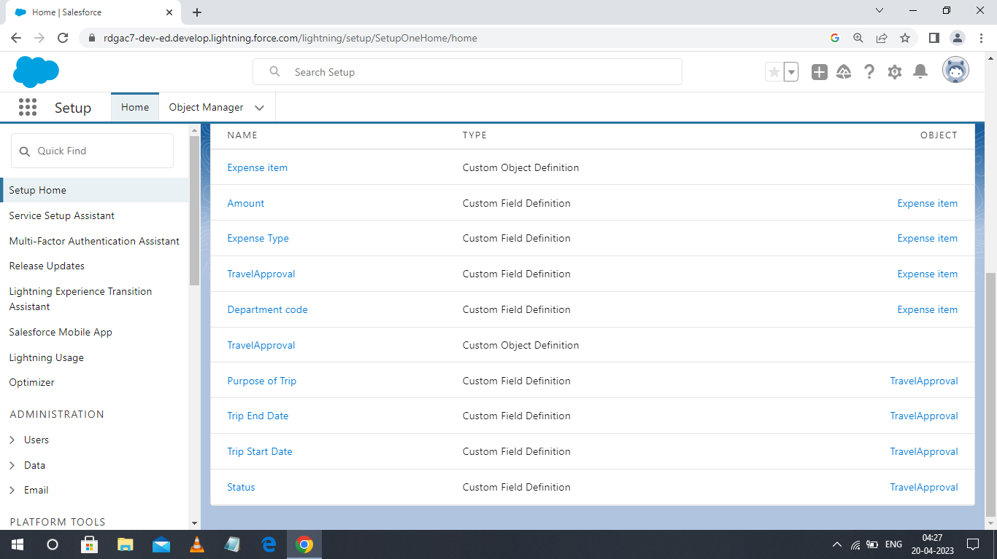

* **Custom Object- TRAVEL APPROVAL**

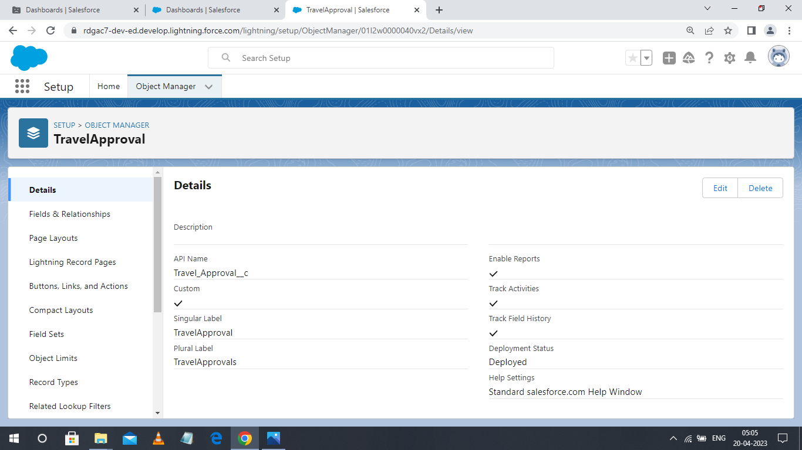

* **Custom Object- DEPARTMENT**

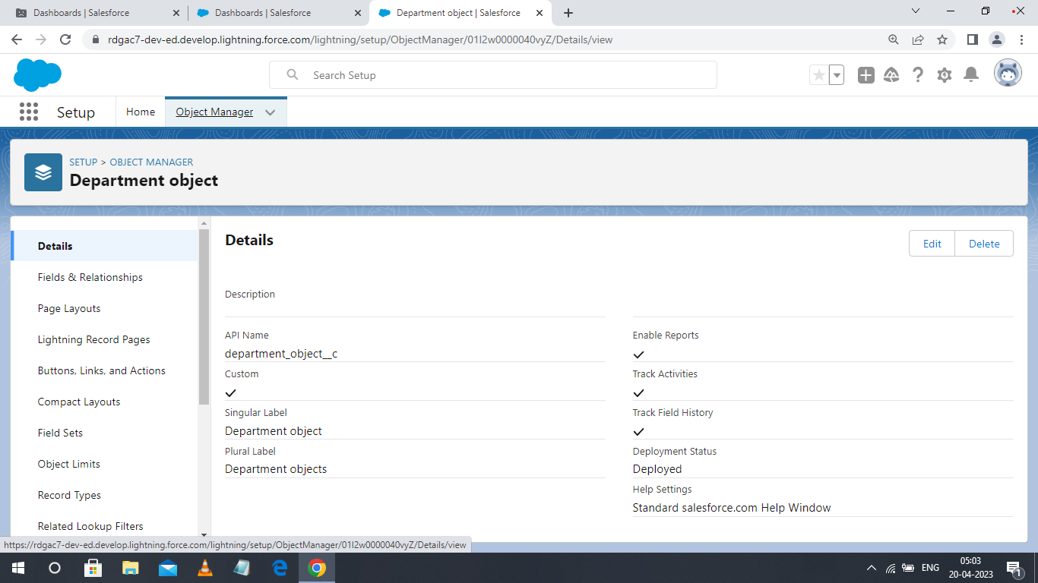

* **Custom Object- Expense Item**

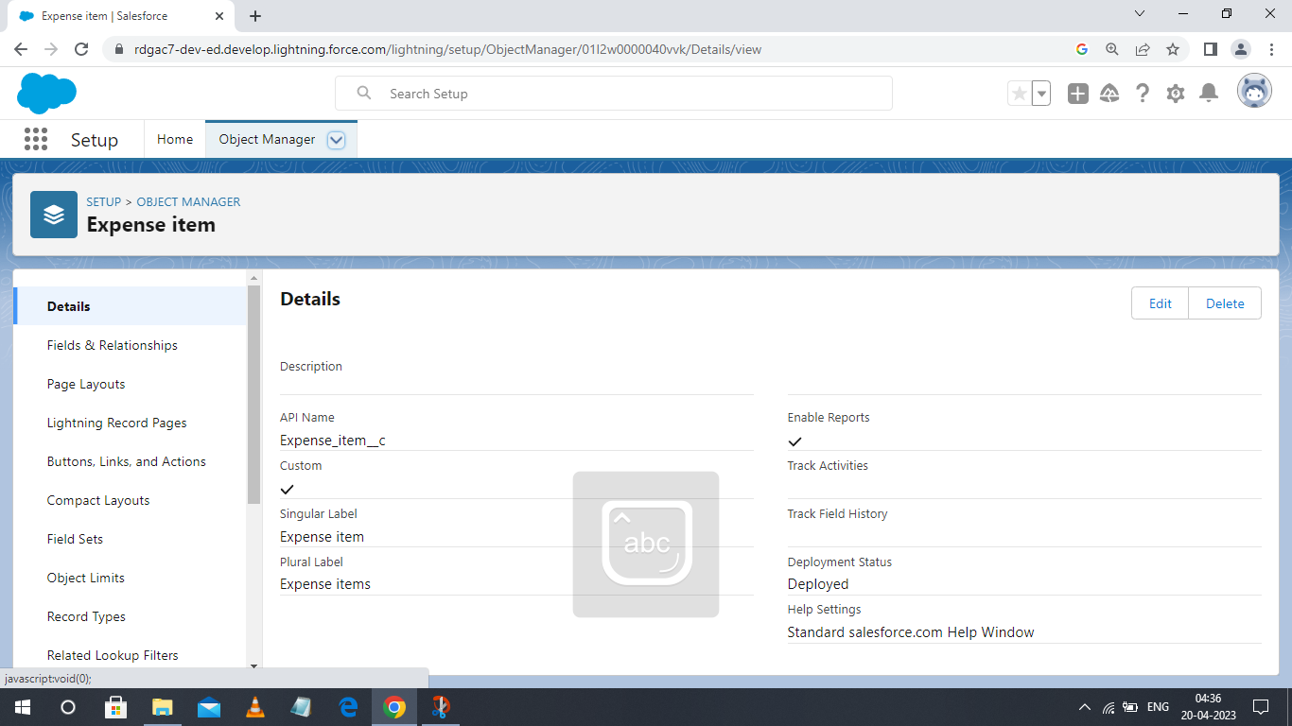

* **Users**

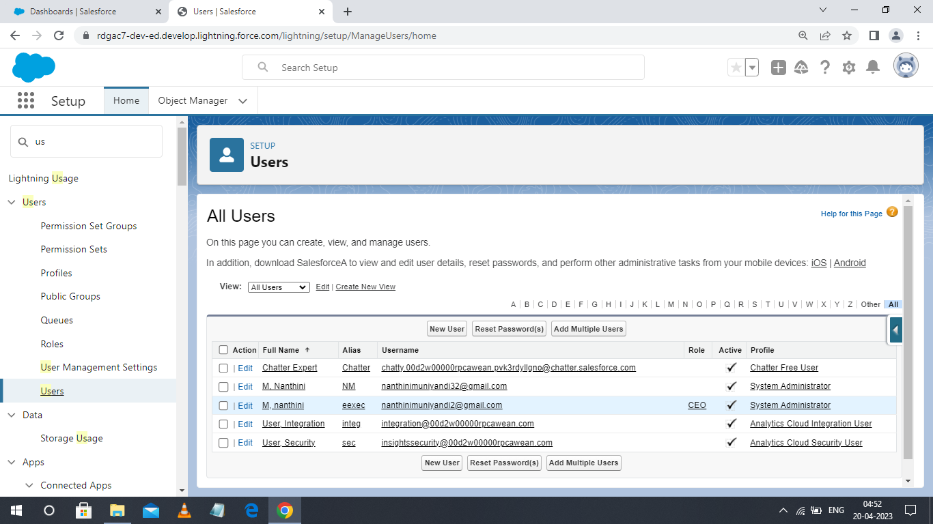

* **Reports**

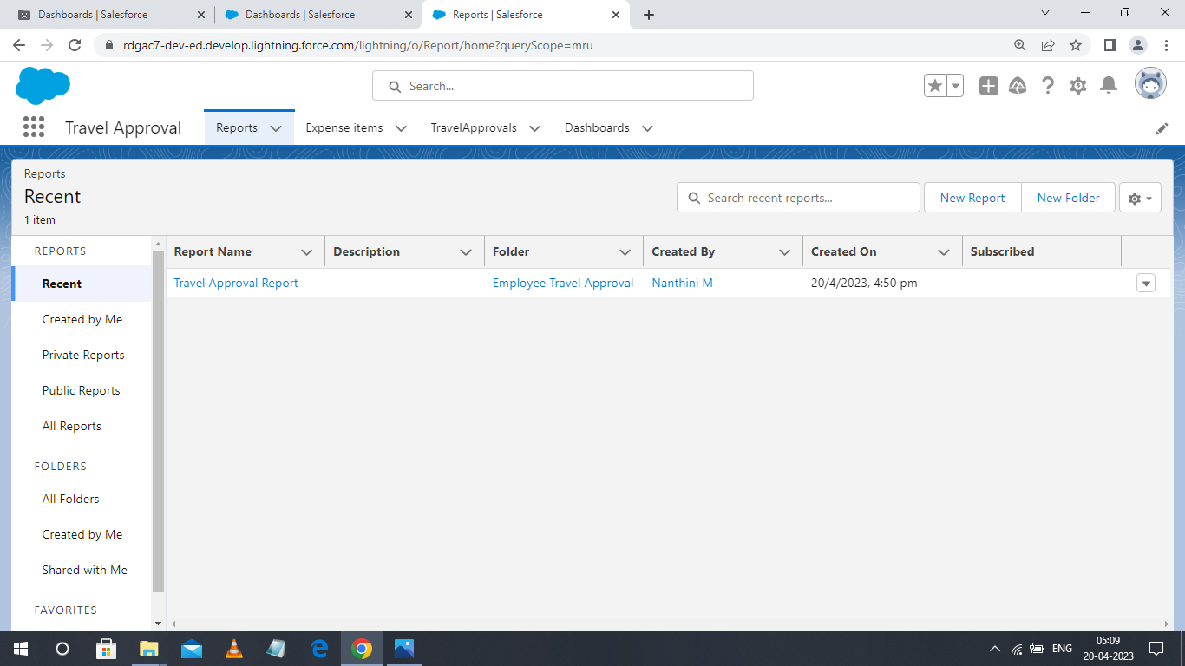

**Dashboards**

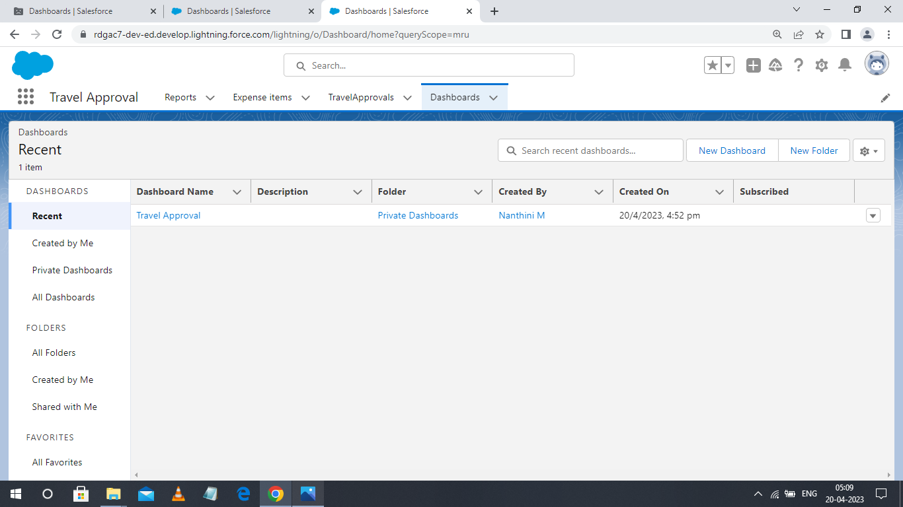

**4. Trailhead Profile Public URL**

**Team leader -** [trailblazer.me/id/nantm3](https://trailblazer.me/id/nantm3)

**Team member 1 -**[trailblazer.me/id/pravp35](https://trailblazer.me/id/pravp35)

**Team member 2 -**[trailblazer.me/id/sathk31](https://trailblazer.me/id/sathk31)

**Team member 3 -**[trailblazer.me/id/smahk1](https://trailblazer.me/id/sathk31)

**5. Advantages & Disadvantages**

|  |  |
| --- | --- |
| **ADVANTAGES** | **DISADVANTAGES** |
| **A travel approval application can streamline the entire process of employee travel approval.** | **Developing and implementing a travel approval application can b e expensive.** |
| **By automating the travel approval process, organization can reduce the time and effort required to manage travel approval requests** | **Some employees and a manger may be resistant to using anew travel approval system.** |
| **A travel approval application can help organizations save money by enforcing travel, policies etc..**  **A travel approval application can help organizations ensure compliance with travel, policies, regulations, and legal requirements.** | **A travel approval application is reliant on technology and software, which can be prone to technical issues such as downtime.**  **The travel approval application will store sensitive employee and company data, so it, must be deigned to ensure data security and protect against cyber threats.** |

**6. APPLICATIONS**

* **An employee travel approval application can also use a part of HR management to track employee leaves, travel, and expenses. It can simplify the processor requesting ad approving leave, ensuring that all necessary approvals are obtained before employee leaves the company.**
* **An employee travel approval application can be used to track and manage travel-related expenses, including airfare, hotel stays, car rentals, and other related expenses.**
* **Employee travel approval application can also helps companies comply with regulatory requirements by ensuring that travel expenses are properly documented and reported. It can help companies avoid potential legal or regulatory issues related to travel expenses.**

**7. Conclusion**

* **Such an application can also provide greater visibility into employee travel plans, allowing managers to make informed decisions about whether a particular trip is necessary and align with company goals.**
* **Overall, an employee travel approval application can benefit both employees and employers, leading to greater efficiency, cost savings, and improved travel managements.**

**8. Future scope**

**In future,**

**The employee travel approval application can be integrated with emerging technologies such as artificial intelligence, machine learning, and block chain to improve the efficiency and security of the application.**

**With the increasing use of mobiles, the employee travel approval application can be developed with a mobile-first approach to make it more accessible and convenient for employees**